|  |
| --- |
|  |
| Progressive Games Engine Assignment |
| Golf Game |

|  |
| --- |
| Eimantas Stoskus  P2672054 |

Contents

Design 2

Game Idea 2

Narrative 2

# Design

## Game Idea

My plan for the project is to create a simple golf game using Unreal’s physics. For the advanced techniques, I will incorporate physics and collision techniques, user interface and HUD, and multiple levels and level design. The idea is to add an impulse to the ball towards the location the camera is facing and to use mouse movement to determine the strength of the impulse applied to the golf ball.

## Narrative

The narrative of the game is that you are a fan of mini golf, and you found an interesting course that you wanted to try and beat. You deicide to find out where this gold course is and travel to it.

# Implementation

## Golf ball

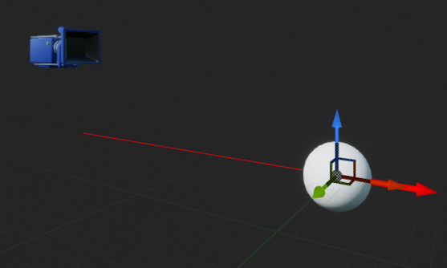I began by creating an interactable golf that had a camera orbiting around it. For this, I used to attach a camera to a spring which was parented to the golf ball. I then made the camera move around based on mouse input.

